School Supply List
Marvin Moss Elementary
Miss Foster’s Pre-K
2025-2026
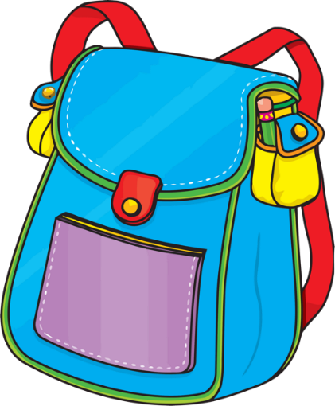
2 Rolls Paper Towels
2 Boxes of Kleenex
2 packages of Baby Wipes
2 containers of disinfecting wipes
2 bottles of Lysol spray

Each afternoon our students will be having a snack. Please consider adding to our snack cabinet by providing snacks that can be passed out such as: goldfish, pretzels, fruit snacks, animal crackers, popcorn, cheese, crackers, juice boxes. Fresh Fruit is also a good option but please check with me first regarding allergies.

